Curriculum vitae of
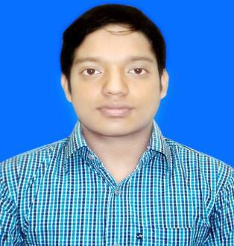

MD: Abu Bakkar Siddik

House: 59, Monipuripara, Farmgate, Dhaka-1215
Contact no: +8801740124863

Email: abakkar.a27@gmail.com

CAREER OBJECTIVE

To obtain a suitable job position in a reputed organization where nice working environment and decision making opportunities will enable me to contribute my best afford for the organization and attaining higher career building opportunities may be assured.

EDUCATION QUALIFICATIONS

Higher school certificate (HSC)

• Institution name : Govt. Azizul Haque College, Bogra

• Board : Rajshahi

- Year of completion : 2014

• GPA : 4.60 out of 5.00

Secondary school certificate (SSC)

•
•
•
•

Institution name : Shihali High School

Board : Rajshahi

Year of completion : 2012

GPA : 5.00 out of 5.00

Skills

Computer:

- Operating System: Windows Xp, Windows 2000, Windows Vista, Windows 7.

- Application Software: : Ms Word, Ms Excel, Ms Power Point, Photoshop.

• Internet : Online Data Entry, Data Research.

Language and communication skills

• Bangla : Mother tongue

• English : Fluent in reading, writing & spoken.

1 of 2

PERSONAL DETAILS

Name | : | Abu Bakkar Siddik
Nick Name | : | Bakkar
Father Name | : | Md: Belal Hossain
Mother Name | : | Late Altafun Nesa
Date Of Birth | : | 30 June, 1996
Nationality | : | Bangladeshi
Religion | : | Muslim
Gender | : | Male
Marital Status | : | Single
Height | : | 5’ 3”

Permanent Address: Village: Shihali Moddha Para P.O: Shihali Hut P.S: Shibgonj

District: Bogra , Bangladesh

Present Address : House: 59 Monipuripara, Farmgate,Dhaka

REFERENCE

Engr. Ariful Islam | Md. Abdur Rasid
FS Promotion & Life Style ltd. | Head Teacher
Dhanmondi, Dhaka | Shihali High School, Shibganj, Bogra
Contact No: 01714942630 | Contact No: 01911993342

DECLARATION

I hereby declare that all the details mentioned above are my own and true to the best of my knowledge.

………………………..

Signature & Date

2 of 2

